CAS PY 106

In Class Note 8

1. Capacitors
2. Capacitors are electric circuit components that can store electric charge and energy
3. They are not same as batteries. Batteries convert chemical energy into electrostatic energy
4. Symbol for capacitor

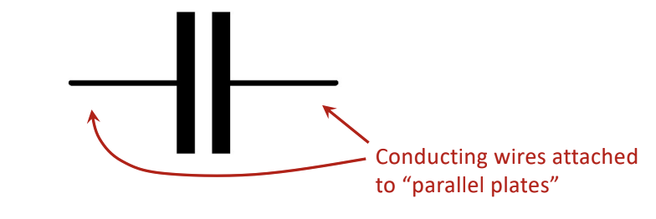

1. Inside the capacitor: two parallel planes
2. 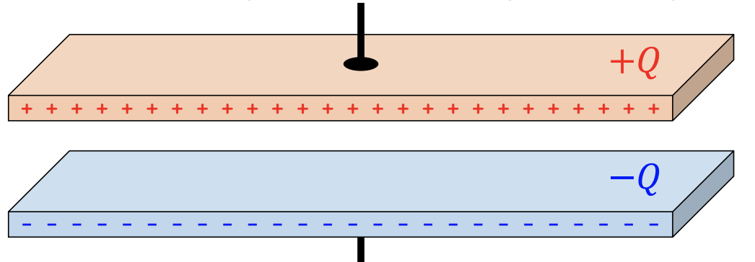
3. Capacitance C describes how much charge can be stored on plates
4. There are several equations used to describe capacitance:

C = Q/delta V

Q = C \* delta V

1. Capacitance also depends on how you construct capacitor, so this isn’t the only equation we can use
2. Units of capacitance: farad (F)

1F = 1C/V

1. Capacitance of parallel-plate capacitor

C = k \* e\*A/d

1. C = capacitance
2. K = “kappa” or “dielectric constant”. This constant depends on material between the plates

K = 1 (vacuum)

K is about 1 (air)

1. A = Area of each plate (in m^2) – assuming that both plates are same size
2. D = distance between plates (in m)
3. Now with insulating material in between plates
4. 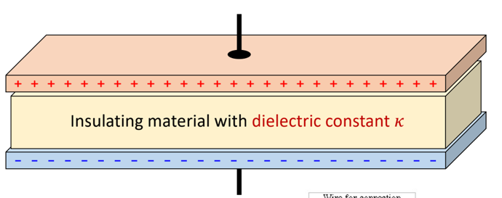
5. 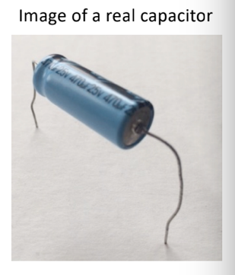
6. Two very large planes, separated by insulating material
7. Dielectric constant k of different materials
8. 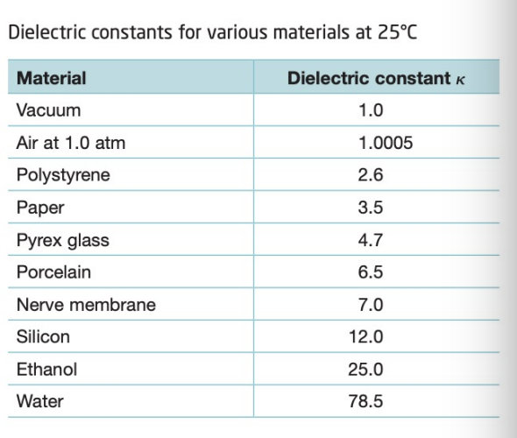
9. Inserting dielectric material weakens the effective E-field intensity between plates, resulting in larger capacitance

C = Q/delta V = Q/Ed since delta V = Ed

1. How do we charge a capacitor?
2. 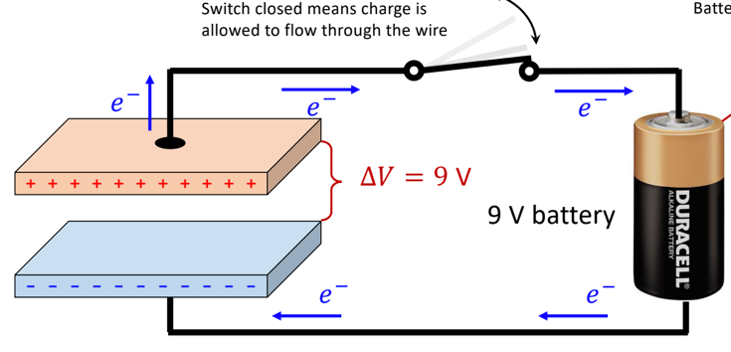
3. 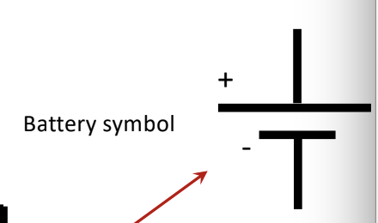
4. A battery uses chemical potential energy to move charge through a closed circuit
5. Electrons will flow out of minus terminal and into the positive terminal
6. Charging stops once electric potential difference between capacitor plates is equal to the battery voltage (9V in this case)
7. Energy stored in a capacitor
8. You cannot charge a capacitor without doing some work to move each electron through the change in potential, from positive plate to negative plate
9. Electrons don’t want to leave positive side. In this case, work is done by battery
10. Electric force is conservative. This means that work done by battery to move electrons from positive plate to negative plate is always same, regardless of electron’s particular path between the plates
11. Each electron is moving along a path that isn’t going directly between plates.
12. However, work required to move each electron from top plate to bottom plate is U=q\*delta V. The work is same if electrons were to move on a direct path downward, from top plate to bottom plate
13. The average potential of capacitor, while its potential increases from 0 to V, simply V/2 (assuming potential increases at constant rate over time)
14. We say that total energy stored in capacitor after moving Q total charge from one plate to other is

U = ½ \* Q \* delta V

1. We can use C = Q/V

U = ½ \* C \* V^2

OR

U = Q^2/2C

1. Does V change?
2. You have a capacitor that is charged by applying potential difference V across the plates. After charging, voltage source is disconnected from capacitor (so each plate is isolated). Does V change when the plates are pulled farther apart?
3. Yes
4. Plates are isolated, meaning that charge Q does not change. No charge enters or leaves the plate
5. C = k\*e\*A/d 🡪 when we increase d, C decreases
6. V = Q/C 🡪 Q doesn’t change but C decreases 🡪 V increases
7. Charging capacitor
8. Example 1:

How much energy is stored in 6600 \* 10^-6 F capacitor charged with 9V potential difference?

U = ½ \* C \* V^2

= ½ \* (6600\*10^-6) \* 9^2

= 0.27 J

1. Example 2:

How much energy is stored in 8\*10^-6 F capacitor charged with 5000V potential difference?

U = ½ \* C \* V^2

= ½ \* (8\*10^-6) \* 5000^2

= 100J